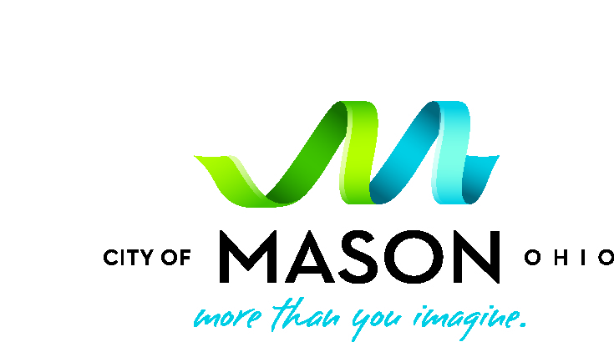
Print form, fill out and mail to:
City of Mason Volunteer Program
City of Mason
6050 Mason-Montgomery Road
Mason, OH 45040

Volunteer BASKETBALL COACH

APPLICATION FORM
Please check what applies:
Head Coach -or- Assistant Coach with _________________________
Boys – or- Girls
What Grade are you coaching?____________

Name |  |  |  |  |  |  | Date
Address |  |  | City |  |  |  | Zip code
Email |  |  | CELL PHONE |  |  |  | Home phone
Drivers license or Ohio ID # |  |  | 10 – 13 14 – 18 |  | 19 – 30 31 – 54 55+
EMERGENCY CONTACT: Name #1 |  |  |  | Name #2
Address |  |  |  | Address
Relationship | Day phone | Night phone |  | Relationship |  | Day phone |  | Night phone
Have you ever been convicted of a felony or misdemeanor? yes no
List all convictions (including date and name and location of court where convicted) after your 18th birthday. (You are not required to list a record, which has been expunged.) A “yes” answer is not an automatic bar to placement, but an untrue answer will disqualify you. If yes, please explain fully below. Attach a separate sheet if necessary.
Are you NAYS/NYSCA certified? Yes No If yes, list your certification ID# and expiration date___________
*expiration date must be through March of the following year (March 2026). If you are not certified go to www.nays.org and do the on-line certification for coaches. email the cert, along with # and expiration date to KALBIN@MASONOH.ORG Member ID: ________________ Expiration Date _________________

Have you completed the concussion training? Yes No If yes, list your date of completion _____________
*if no, go to The national federation of state high school associations (nfhs) and do the on-line certification for coaches. email the certificate to KALBIN@MASONOH.ORG *Valid for 3 years from completion date

I certify that all statements I have made on this application and on other supplementary material are true and correct. I hereby authorize the City of Mason to investigate the accuracy of this information. I am aware that fingerprinting may be required before placement in some positions. I understand that I am working at all times on a voluntary basis, without monetary compensation or benefits, and not as a paid employee. The City of Mason reserves the right to terminate a volunteer’s services at any time.

Release of All Claims and Agreement Not to Sue
As additional consideration of my application and permitting me the opportunity to participate in recreational activities and to
utilize the facilities at the Mason Community Center, the undersigned hereby waives, releases, discharges, saves, holds harmless,
and indemnifies the City of Mason and the Mason City School District, their employees, volunteers, agents, and independent
contractors, from any and all claims of whatever kind, to me, my spouse, or my dependents which may directly or indirectly
arise. I hereby agree to accept any and all risk of personal injury, illness, death, or property damage and verify this statement
by placing my signature below. Furthermore, by signing below for myself, my dependents, and/or my spouse, I understand this
release bars claims by the undersigned’s spouse, dependents, heirs, assigns, executors, and administrators.
I understand that photographs and/or videotapes of me and my family members may be taken for use in promoting the City of
Mason activities and facilities in future editions of CenterPoint, in a variety of other publications, on display boards throughout
the Community Center and for other uses by the City of Mason. I hereby give my permission to use such photographs without
compensation to me.
I HEREBY CERTIFY THAT I HAVE CAREFULLY READ THIS DOCUMENT AND I FULLY UNDERSTAND ITS CONTENT. I AM
AWARE THAT THIS IS A RELEASE OF LIABILITY AND A LEGAL CONTRACT AND THAT IT AFFECTS MY LEGAL RIGHTS. I
AM SIGNING THIS DOCUMENT OF MY OWN FREE WILL.
_________________________________________________________________________________________________________________________
Signature of Applicant_________________________________________________ Date_______________________

Signature of Parent or Guardian (if applicant is a minor) ________________________________________________

Dear volunteer basketball coach prospects,

Mason is delighted that you would consider serving the children in this community by volunteering to coach youth basketball. Our foremost concern is the safety of the children and we will take reasonable measure to ensure their safety.
We ask that you provide a new application this year so that we are assured of having the most up to date contact information. Also, we have made it a policy to require a background check every year, even for our returning coaches. We hope you will recognize the importance of ensuring our Mason residents that we value a healthy and safe play environment for their children. The few minutes we ask you to sacrifice for this process is well worth it if we can avoid incidents.
To simplify the process, here is what we ask each head coach and assistant coach to do:
- Complete the Volunteer Application (regardless of you being a returning coach).
- Go to the police department to get fingerprinted. Please be sure to bring a valid photo ID (drivers license, passport, or State ID card)
  - Anytime Monday-Friday between 8:00 am and 4:00 pm
Note-Regarding the background check, your fingerprints are scanned and sent electronically to the Ohio Bureau of Criminal Identifications criminal database. The fingerprints are run through for COMPARISON ONLY, to see if you have ever been fingerprinted on an arrest or criminal offense charge. Your record check is performed and the fingerprints are never kept in the system. The background check is then only good from year to year. Thus the reason for having to do this every year.
- Provide your NAYS/NYSCA (National Youth Sports Coaches Association) certification number and expiration date on the application if your certification is current. The certification needs to be current through the next year (March 2025). If you need to renew or get NYSCA certified, please go to www.nays.org and follow the links for NYSCA online.
- Complete the Youth Sports Concussion Training The National Federation of State High School Associations (NFHS). This certification is good for 3 years from the completion date.
- Once all items have been completed, send all documents together (volunteer application form, NAYS certification # and expiration date, as well as the Concussion Certification) in one email to Keith Albin at kalbin@masonoh.org. Please do not send separately.

Final Deadline: OCT 18th. It will take a few weeks for the background check and our other internal processes. Please anticipate a delay in providing your services if you are unable to meet this deadline.

Keith Albin
Volunteer Coordinator
513-229-8555 ext. 5548
kalbin@masonoh.org

